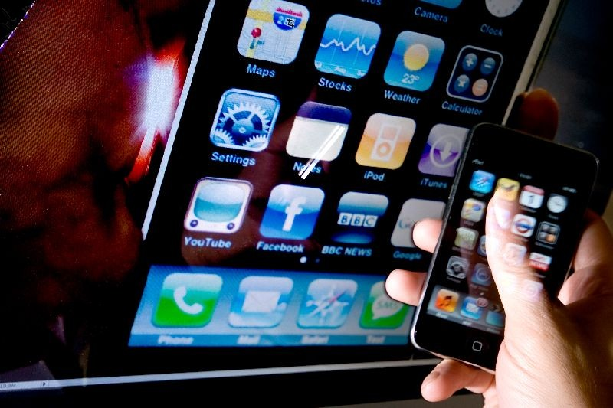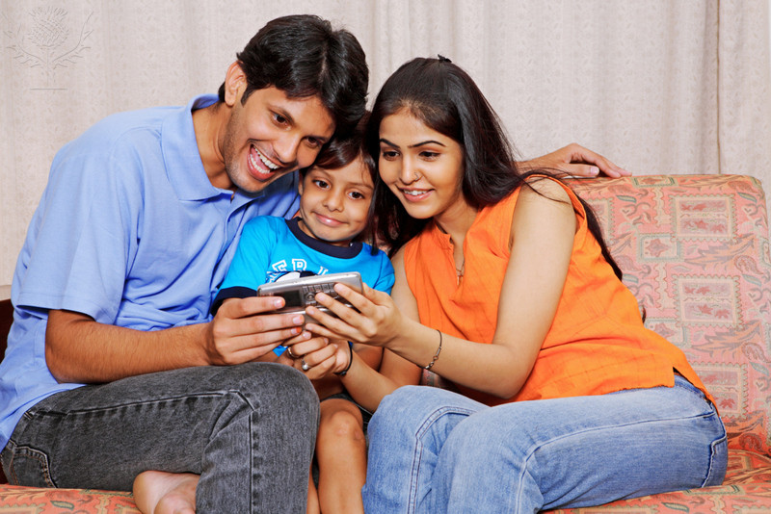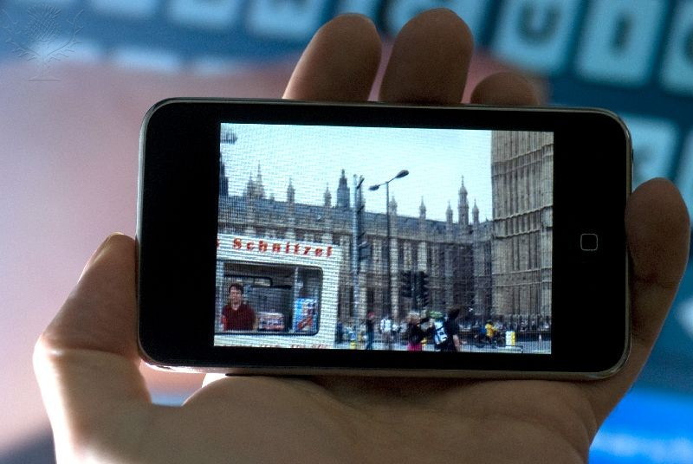

**www.yourbestfamily.com**

**©2014 Ryan Smith, LPC, LMFT**

13

**No choosing phones over kids**

14

**Add your own here**

Add your own here

*Tech free time is flexible and will be implemented by request. A 10-minute notice must be given

# Everyday, Everyone

Smith Family Technology Plan

**Pictures of kids posted online must be approved by kids first**

06

No arguing if a parents asks to see my phone

No devices during family meals, game time, or tech free time*

03

09

**Add your own here**

Add your own here

05

02

01

04

12

11

07

08

10

**No devices during sleeping hours**

**No work contact after ________**

# Kids

Parents

Devices/Internet may not be used to hurt people inside or outside of the family

All morning goals must be met before I get my phone for the day

Kids

No secret social media/email/networking accounts

No locked screens

All devices charge in master bedroom at night (no devices in kids rooms during sleeping hours)

Devices must be put away by ________ weeknights and _______ weekends

Not arguing about your phone being taken away will allow you to reduce your penalty time by 50%

25-30

Add your own here

Add penalty for parent slip-ups here

19-21

Add your own here

15-18

Add your own here

10-14

Add your own here

4-9

Devices surrendered for 48 hours

Devices surrendered for 24 hours

Slip-Ups

Add comments here

1-3

18

Add your own here

Add your own here

28

27

26

25

30

29

Add your own here

24

Add your own here

21

17

_____________________________

_____________________________

_____________________________

_____________________________

_____________________________

# Family Signatures

I agree to the family plan:

# Reminders

Add clarifications here

20

Add your own here

Add your own here

# Add Yours Here

19

Family Goals

15

16

No pictures may be posted/sent that parents would not approve of

No making fun of, complaining about, or being mean to people online

# Social Media

23

Create and maintain a shared family calendar.

Connect as a family on a networking app.

22

Add your own here

Broken phones don’t get replaced

Calls or texts from parents are answered

Data plans are limited

Devices are not private